

**POLYTRA - FRACHT buys CARGO SERV in SOUTH AFRICA**

Dear friends,

Last week Polytra – Fracht significantly expanded its activities in South Africa by acquiring 51% of CARGO SERV.

CARGO SERV operates in DURBAN SOUTH AFRICA since 1994 – initially specialised in transport freight forwarding but since 2015 also a well-known and respected warehouse operator – offering more than 38 000 square meters of warehousing facilities.

CARGO SERV is a proud service provider for major African importers such as WFP – Michelin – Sumitomo and several Brewers and major mining companies in the Sub Saharan region.

CARGO SERV also offers clearing solutions under its own clearing license – transport solution with its own trucking fleet and can handle both containers and project cargo with its own combilift and yard operations.

CARGO SERV currently employs 41 full time staff.

CARGO SERV currently has a BBEEE status of 2 but will most likely fall to 4 due to its rapidly increased turnover. Level 4 is still 100 % BBEEE compliance, which is an excellent standing.

POLYTRA SOUTH AFRICA – will work closely with CARGO SERV especially for warehousing and Durban port operations to secure and organise important projects for the South African and neighbouring markets.

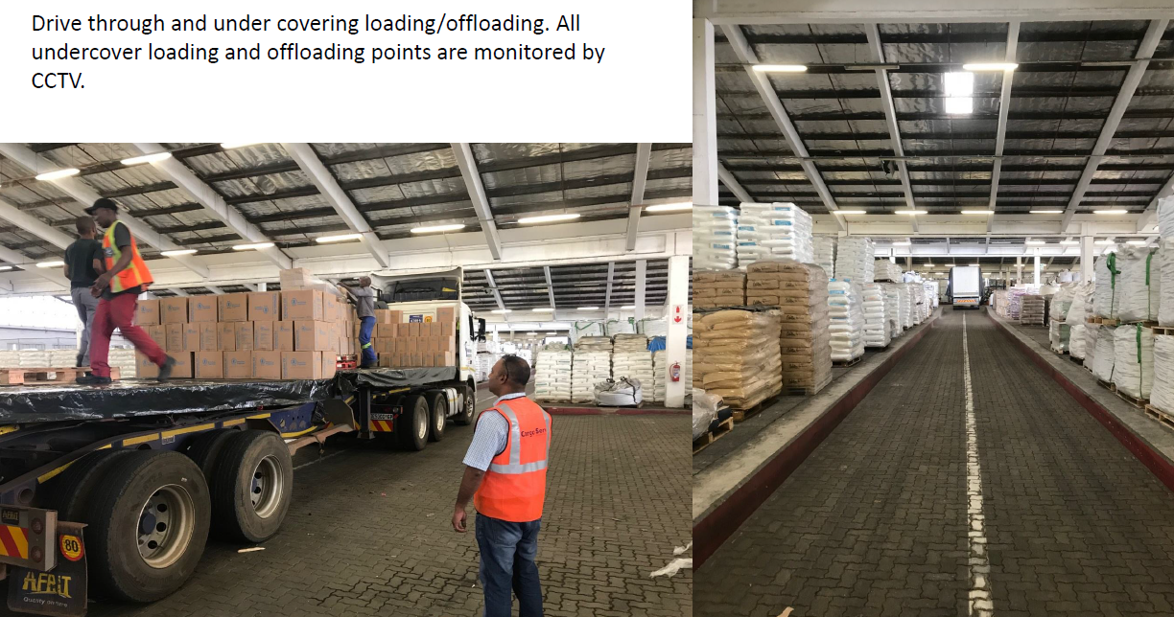

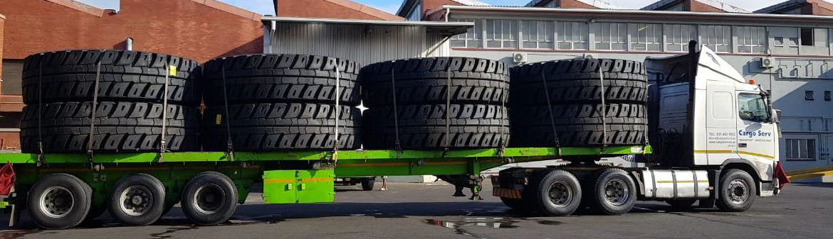

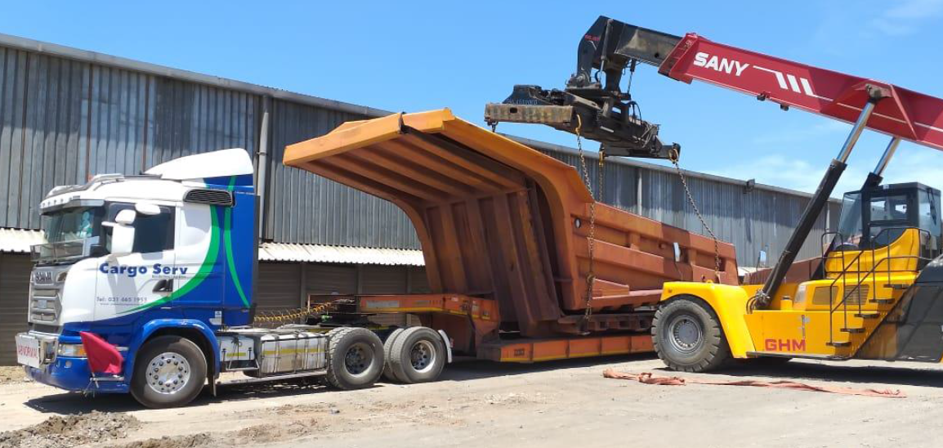



We are very happy to have CARGO SERV on bord.

Best regards

|  |  |  |  |  |  |  |  |  |  |  |  |  |  |  |  |  |  |  |  |  |  |  |  |  |  |
| --- | --- | --- | --- | --- | --- | --- | --- | --- | --- | --- | --- | --- | --- | --- | --- | --- | --- | --- | --- | --- | --- | --- | --- | --- | --- |
| |  |  |  |  |  | | --- | --- | --- | --- | --- | | |  |  |  |  | | --- | --- | --- | --- | | |  | | --- | | **AMAURY LUYCKX​** | | **|** | **MANAGING DIRECTOR** | | | |  |  |  |  |  |  | | --- | --- | --- | --- | --- | --- | | cid:image001.png@01D4F52F.42C7B7C0 | [aluyckx@polytra.be](mailto:aluyckx@polytra.be) | cid:image002.png@01D4F52F.42C7B7C0 | [+32 3 205 04 73](tel:+32%203%20205%2004%2073) | cid:image003.png@01D4F52F.42C7B7C0 | Potvlietlaan 7, 2600 Berchem, Belgium | | cid:image004.png@01D4F52F.42C7B7C0 | [www.polytra.be](http://www.polytra.be/) | cid:image005.png@01D4F52F.42C7B7C0 | [+32 472 189 274](tel:+32%20472%20189%20274) | |  |  |  | | --- | --- | --- | | VAT | |  | | --- | | BE 0414.348.267 | RPR Antwerpen | | | | | | |  | | --- | | cid:image006.png@01D4F52F.42C7B7C0 | | |  | | --- | |  | | | |